Content | Page(s)
- Running EasyPHP | 2
- Using EasyPHP | 3-5
- Access and Manage MySQL Database | 6-7
- Troubleshooting | 8-11
- Recommended Editor Tools to Download (Optional) | 12
- More help with EasyPHP? | 13

- Running EasyPHP

  - After installing EasyPHP successfully, we can start using the program immediately.

  - Start>All Programs> EasyPHP> EasyPHP Program

  - You should see a similar interface shown below when EasyPHP is running.

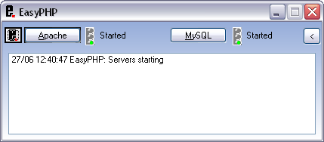

  - Usually, Apache and MySQL servers will run automatically and show that they have “started” as seen above.

- Using EasyPHP

  - After you have started running EasyPHP successfully, you can now start using it immediately.

  - Place all your “.php” files in C: Drive> My Programs> EasyPHP> www folder. This is the default directory when you install EasyPHP.

  - You can use any internet browsers to view your “.php” files.

  - To access the “.php” file manually, type this URL, http://127.0.0.1/filename.php and you will be able to view the file.

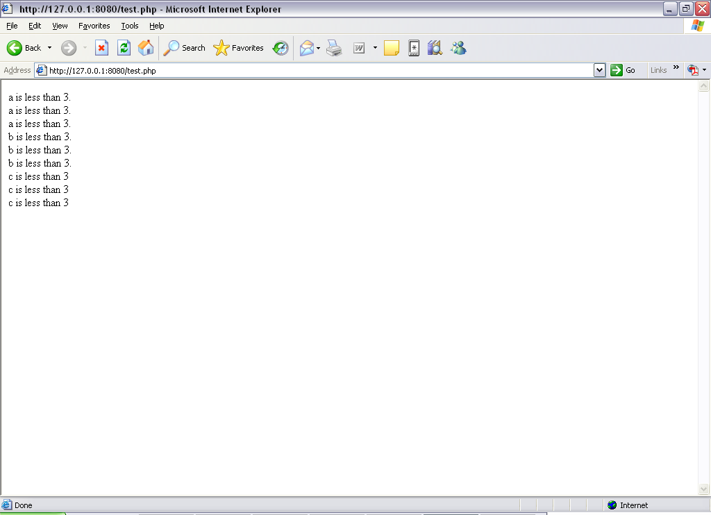

  - There is another way to access your “.php” file and that is by using a graphical user interface. Click on the icon> Local Web. Notice that it will only show the folders inside “www” folder.

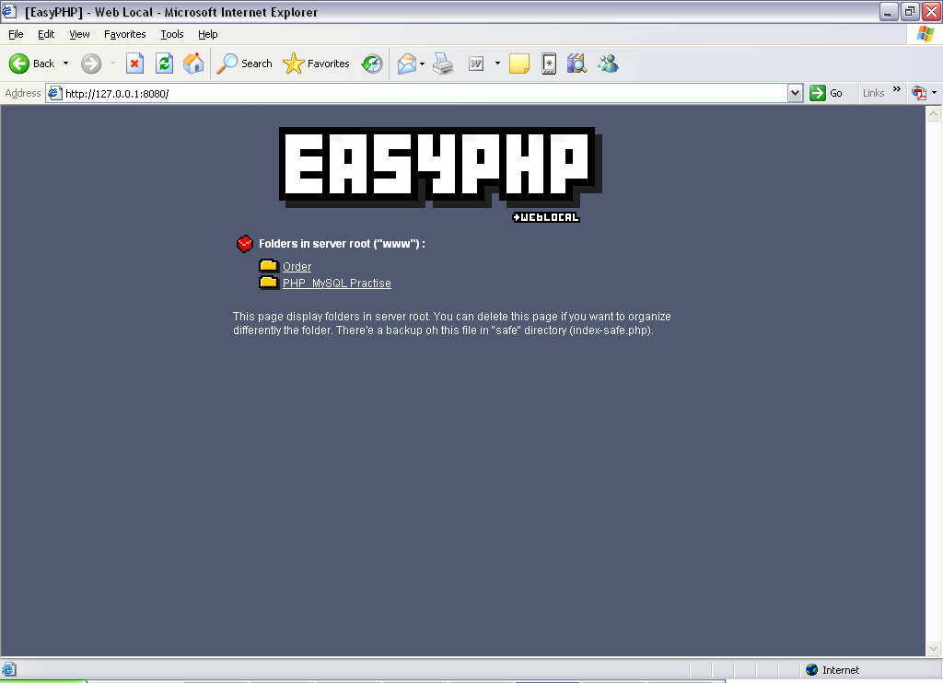

  - From the interface shown above, there are two folders inside the “www” folder. Click on the folder that you wish to open.

  - After clicking on one of the folders, you can see a similar interface as shown below. This page will display all the “.php” files and other files that you have installed inside the folder.

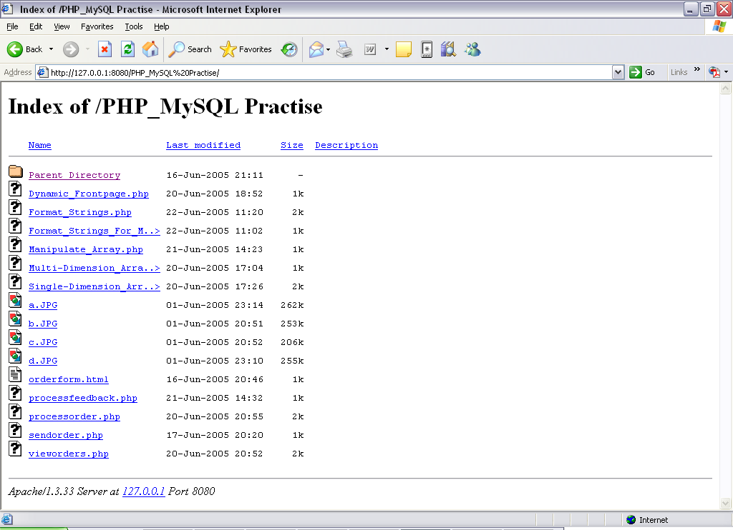

  - Click on any file that you wish to open.

- Access and Manage MySQL Database

  - To access MySQL click on the icon> Administration. You will be directed to a similar page as shown below. Note that the URL address will be http://127.0.0.1/home/, if you have no other web servers installed.

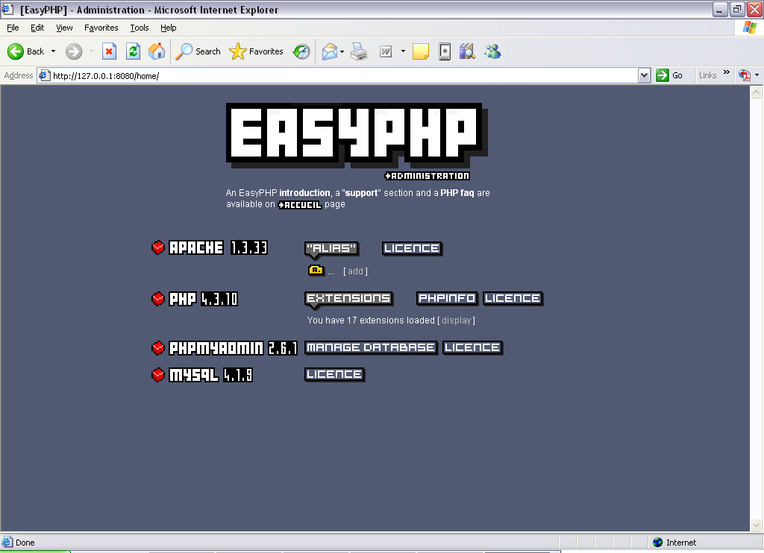

  - Click on “Manage Database” to access and manage MySQL database. You will be directed to a similar interface as shown below.

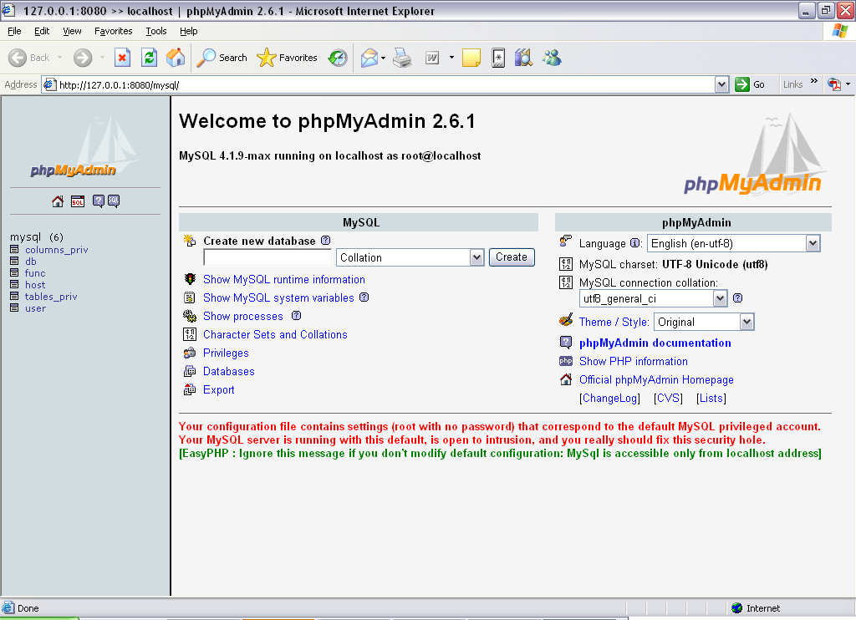

  - From here, you can manipulate all your databases and access it locally.

- Troubleshooting

  - Apache not working

    - If you see a similar interface as shown below, try to restart your server again. Click on Apache>Restart

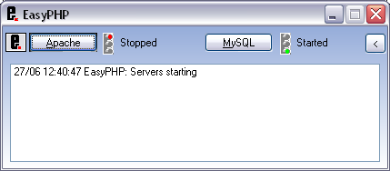

    - If Apache still does not start, it is most likely due to a port conflict between Apache and another web server installed in your computer.

    - You will also notice when you click on the icon, you will not be able to access MySQL and the files in the “www” folder through the Graphical User Interface.

    - Therefore, you will need to change the virtual port used by Apache.

    - Click on the icon> Configuration> Apache, to configure the port used by Apache server.

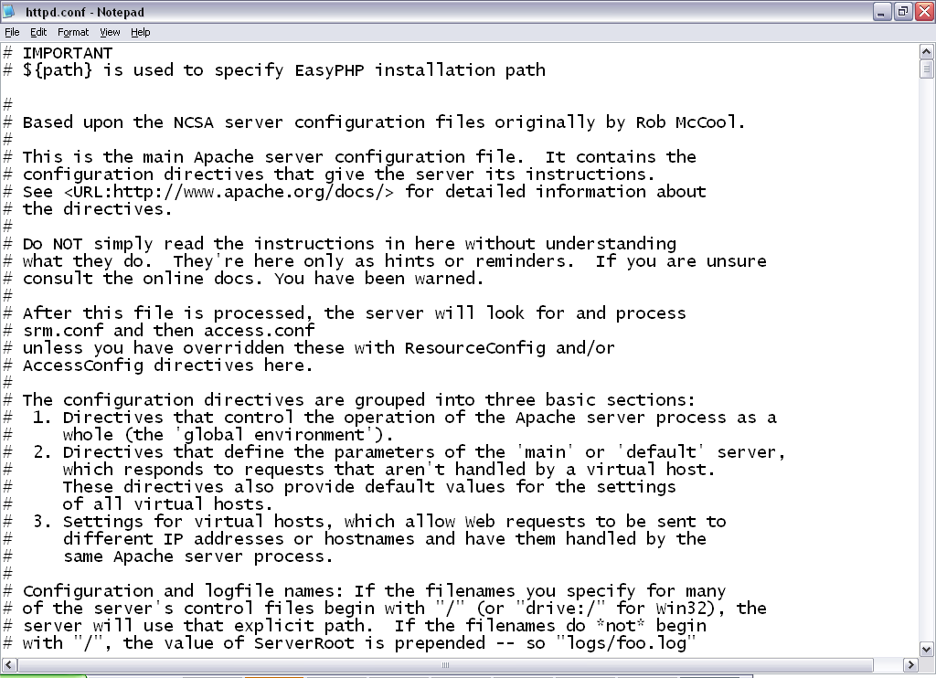

    - Click on Ctrl+f to do a word search of “Port 80” and the search will return a highlighted result. Port 80 is the default port used by Apache server.
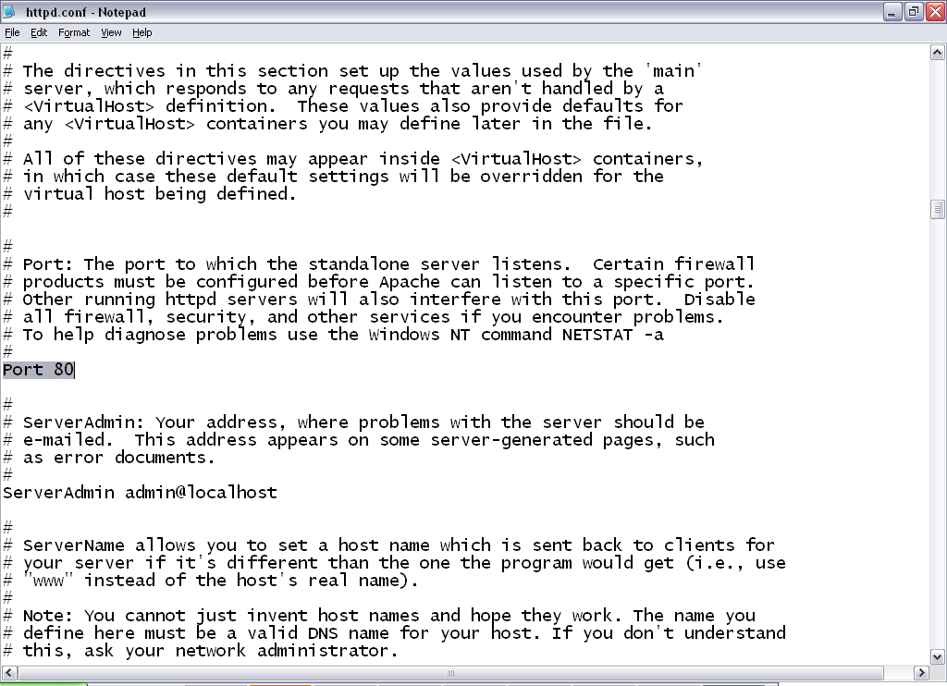

    - Change the port number to anything more than 8000 and we will use 8080.
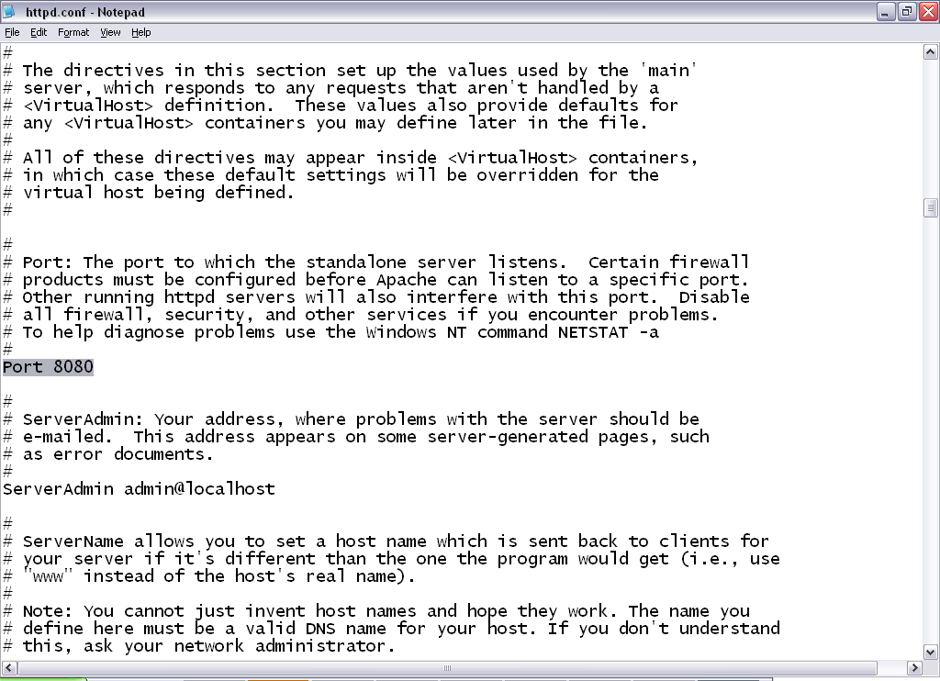

    - Save the file and close it.

    - Click on the icon> Restart. This will restart all your servers. By doing this, Apache should start. If it does not, please restart your computer and run EasyPHP program again as how we did at the beginning.

Recommended Editor Tools to Download (Optional)

I recommend that you use an editor tool to do programming instead of using notepad. Some of the editor tools are able to show line numbers for easy debugging and some can even do syntax highlighting. Here are some of the recommended editor tools to download:

    - Crimson Editor: http://www.crimsoneditor.com/
    - 1stPage: http://www.evrsoft.com/
    - Homesite: http://www.macromedia.com/software/homesite/

- More help with EasyPHP?

If this guide is unable to solve your problem, here are other web sites that may be able to provide help:

- http://www.canowhoopass.com/guides/easyphp/running.php
- http://www.php.net/support.php
- http://www.easyphp.org/faq.php3

